iSinkwe: Automatic Synchronisation of Text Ebooks with Audio

Rynhardt Kruger

21 March 2024
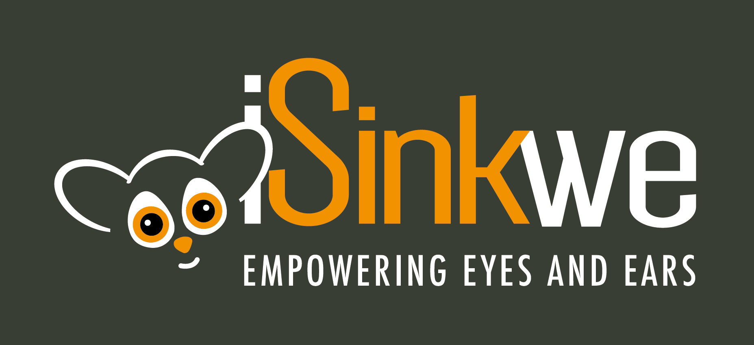

Introduction
- iSinkwe synchronises text ebooks with audio
- Audio either computer generated or human-narrated
- Designed for EPUB3 documents
- iSinkwe means bush baby in isiZulu, a nocturnal African monkey with big eyes and ears
- iSinkwe enables multisensory reading

CSIR (Council for Scientific and Industrial Research)
- National scientific and research organisation
- Researches, develops, localises and diffuses technologies to accelerate socioeconomic prosperity in South Africa
- Human language technologies (ASR, TTS, NLP) in all 11 official spoken languages

Motivation and Context
- Developed in South Africa
- Multilingual, eleven official spoken languages
- Reading barriers: print disabilities, low literacy
- Sporadic internet connectivity

ISinkwe Overview

Components
iSinkwe consist of three components:
- iSinkwe Convert: converts various formats to EPUB3
- iSinkwe Synchronise: synchronises EPUB3 with audio
- iSinkwe Read: EPUB3 reader supporting media overlays

ISinkwe Convert
- Accessible via web interface
- User uploads document in various formats
- Document converted to EPUB3
- EPUB3 available for download

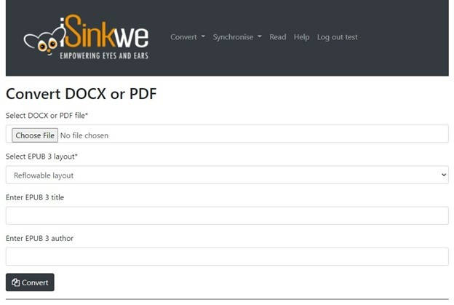
Screenshot of the web interface for iSinkwe Convert width=18cm

ISinkwe Synchronise
- Accessible via web interface
- User uploads EPUB3
- User chooses human or computer audio
- Human-narrated audio fills in chapters with computer audio
- User notified when synchronisation completed
- Augmented EPUB3 available for download

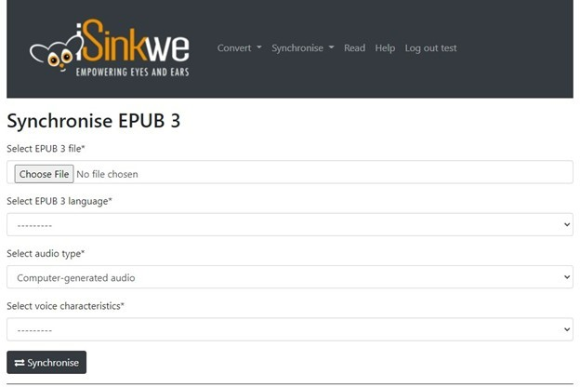
Screenshot of the web interface for iSinkwe Synchronise width=18cm

ISinkwe Read
- EPUB3 Reader supporting media overlays
- Allows navigation in audio by word, sentence, or paragraph
- Synchronised text highlighted on screen
- Playback continuous or on demand
- Search function

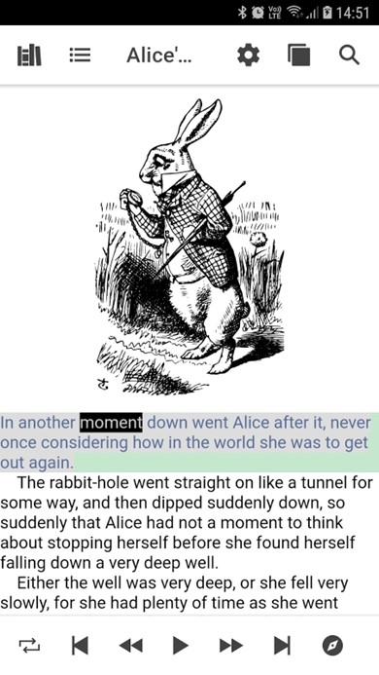
Screenshot of the web interface for iSinkwe Read height=15cm

Technical Description

Computer Generated Audio
- Text synthesised via TTS
- Qfrency TTS for South Africa’s official spoken languages
- TTS audio added to EPUB3

Human-narrated Audio
- TTS compared with human audio for time alignments
- Comparison via dynamic time warping algorithm
- DTW requires language-specific TTS
- South African languages facilitated by Qfrency TTS
- Human audio added to EPUB3

Previous Usability Study

Candidates
- Ten candidates
- Five blind and low-vision users
- Two users from publishing industry
- Three educators of print-disabled learners

Evaluation Description
- Users evaluated iSinkwe Convert, Synchronise, and Read
- Asked to perform tasks with own and provided documents
- Qualitative and quantitative questions, including:
  - What users liked the most
  - What users liked the least
  - Whether they experienced any issues
  - What they would change
  - Rating of the component from 1 to 10

Component Ratings

ISinkwe Convert
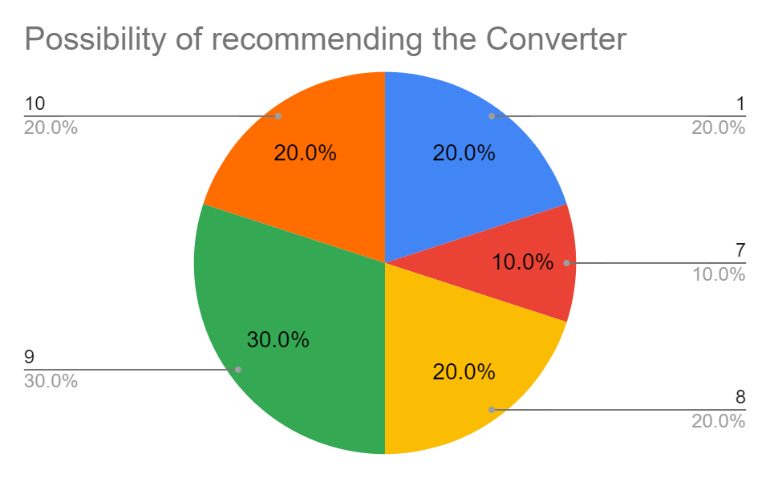
A pi chart depicting the possibility of users recommending iSinkwe Convert to someone they know. 20 percent of users gave a score of one, 10 percent gave a score of 7, 20 percent a score of eight, 30 percent a score of nine, and 20 percent a score of ten. width:18cm

ISinkwe Synchronise
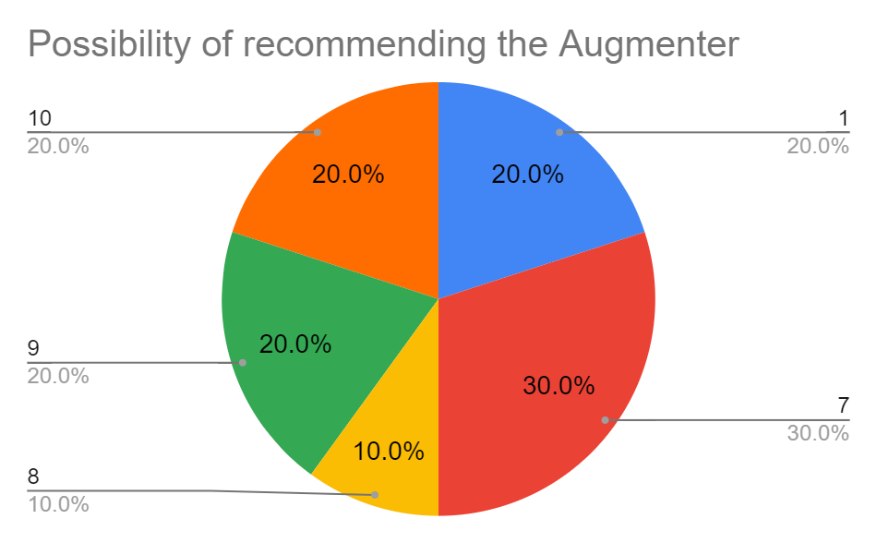
A pi chart depicting the possibility of users recommending iSinkwe Synchronise to someone they know. 20 percent of users gave a score of one, 30 percent a score of seven, 10 percent a score of eight, 20 percent a score of nine, and 20 percent a score of ten. width:18cm

ISinkwe Read
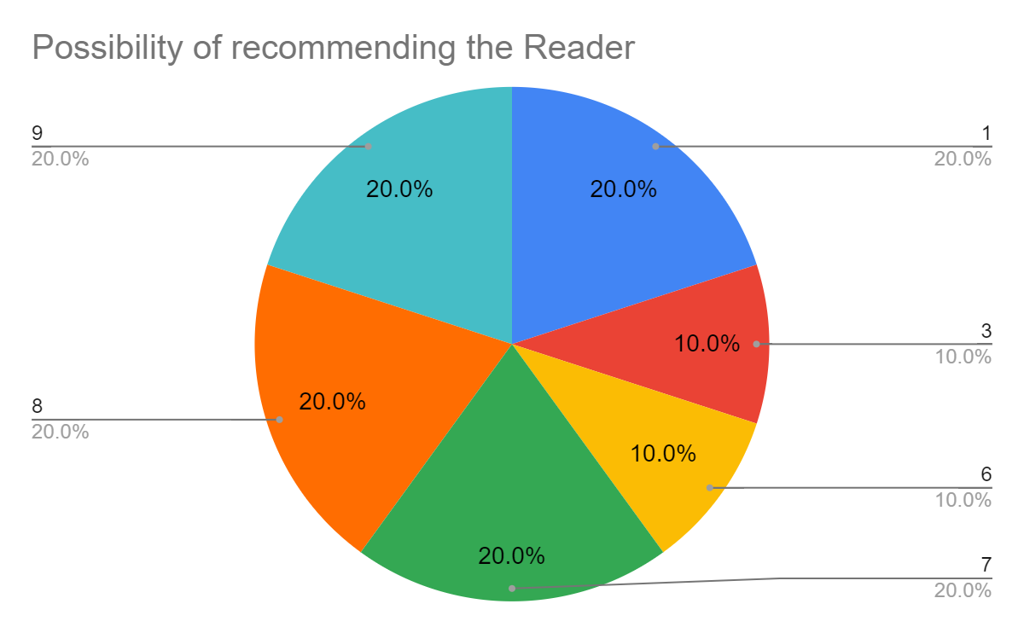
A pi chart depicting the possibility of users recommending iSinkwe Read to someone they know. 20 percent of users gave a score of one, 10 percent a score of three, 10 percent a score of six, 20 percent a score of seven, 20 percent a score of eight, and 20 percent a score of nine. width:18cm

Discussion
- BLV users positive on iSinkwe Convert and Synchronise, suggested WCAG improvements
- BLV users mixed reviews on iSinkwe Read, we focus on existing readers as well
- Publishing industry mainly interested in iSinkwe Convert and Synchronise
- Educators least positive experience with iSinkwe
- Educators use existing AT allowing reading and writing in same document

Future Work
- In development: recognition of mathematics
- Exploration of diagrams

Contact Information
- isinkwe.com
- info@isinkwe.com
- rkruger@csir.co.za

Demo
- Uploading a book to iSinkwe Synchronise
- Reading a book using Thorium
- Reading a book using iSinkwe Read

